|  |  |  |
| --- | --- | --- |
| **S.No.** | **Topic** | **Page No.** |
| 1. | Objective and Scope of the Project | 2 |
| 2. | Problem Definition | 3 |
| 3. | Life Cycle of the Project – ERD | 4 |
| 4. | Details of Hardware and Software used | 6 |
| 5. | SIGN IN Design | 7 |
| 6. | Input Screen Design & Source Code of the Project | 19 |
| 7. | Data Dictionary | 74 |

**CONTENTS**

1. Objective & Scope of the Project

Objective

The main objective of the project is to *computerize the processing of Salary Calculation and Management.*

This package is useful in maintaining *Employee and Attendence details for Salary Processing.*

Scope

This project is developed for a small organization.

Further, it can be easily customized for the use of any other type of firm. This project will help them to create a working system into the latest concept of *paper less office.*

2. Problem Definition

The project “Salary Management System” shows a simple Salary Management procedure conducted in small organizations.

The system should be developed to maintain the employee record and their attendance details.

Customer needs must be taken into account.

A proper database should be maintained in the RDMS and the front end to be developed using advanced GUI interfaces.

The system should be able to handle exceptional situations.

3. Life Cycle of the Project

**System Development Life Cycle (SDLC)**

The System Development Life Cycle (SDLC) is a set of activities that analysts, designers and users carry out to develop and implement an Information System.

The SDLC consists of the following activities.

Feasibility Study

↓

Requirement Definition (Analysis)

↓

Design (Database & Program)

↓

Development of Software

↓

Unit Testing

↓

System Testing

↓

Implementation

↓

Evaluation

↓

Maintenance

Context Diagram

Leave Details

Recruitment

Increment etc. decisions

Enter Details

Monthly Salary Statement

ATTENDENCE

EMPLOYEE

OFFICE STAFF

MANAGEMENT

4. Details of Hardware & Software used

**Platform**: Windows 7

**Tools**: Java NetBeans7.2

**RDBMS**: MySQL

Hardware Specifications

**Microprocessor (CPU)**: Dual Core

**Memory (RAM)**: 4 GB

**Virtual Memory**: 32-bit

**Hard Disk**: 500 GB

**VDU**: SVGA

**Keyboard**: Standard 104 Keys

**Mouse**: Standard 3-buttons Mouse (Scroll)

**Printer**: Inkjet / Laser

Software Specifications

**Operating System**: Windows 7

**Front-End Design** : Java NetBeans 7.2

**Back-End**: MySQL

**Documentation** : Microsoft Word 2010 and MS Paint

5. SIGN IN Design

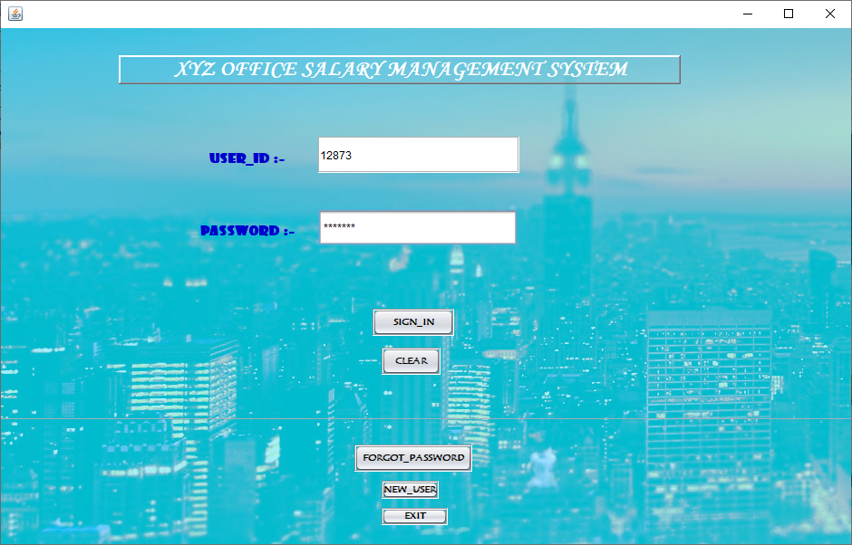

1. CODING FOR SIGN IN BUTTON

private void b1ActionPerformed(java.awt.event.ActionEvent evt) {

String A,B;

A=t1.getText();

B=new String(t2.getPassword());

try{

Class.forName("java.sql.DriverManager");

Connection con = DriverManager.getConnection("jdbc:mysql://localhost:3306/salarymanagement","root","");

String sql;

A=t1.getText();

B=new String(t2.getPassword());

sql="select * from USERS where USER_ID="+A;

System.out.print(sql);

Statement st=con.createStatement();

ResultSet rs=st.executeQuery(sql);

if(rs.next())

{

// JOptionPane.showMessageDialog(null,"INCORRECT USER_ID OR PASSWORD PLEASE CROSS-CHECK OR RESET PASSWORD");

// else{

String a=rs.getString("USER_ID");

String b=rs.getString("password");

if(a.equals(A) && b.equals(B))

{

JOptionPane.showMessageDialog(null,"WELCOME TO XYZ COMPANY");

b1.setVisible(false);

b3.setVisible(false);

b5.setVisible(false);

b4.setVisible(false);

t1.setText("");

t2.setText("");

t1.setEditable(false);

t2.setEditable(false);

dispose();

input_screen s = new input_screen();

s.setVisible(true);

}

else{

JOptionPane.showMessageDialog(this,"INCORRECT USER_ID OR PASSWORD PLEASE CROSS-CHECK OR RESET PASSWORD");

}

}}

catch(Exception e)

{

JOptionPane.showMessageDialog(null,e.getMessage());

JOptionPane.showMessageDialog(null,"INCORRECT USER_ID OR PASSWORD PLEASE CROSS-CHECK OR RESET PASSWORD");

}

}

**FOR CLEAR BUTTON**

t1.setText("");

t2.setText("");

b1.setVisible(true);

**FOR FORGOT PASSWORD BUTTON**

dispose();

forgot_password q = new forgot_password();

q.setVisible(true);

**FOR NEW USER BUTTON**

**login_newuser w = new login_newuser();**

**w.setVisible(true);**

1. **dispose();**

***FORGOT PASSWORD FORM***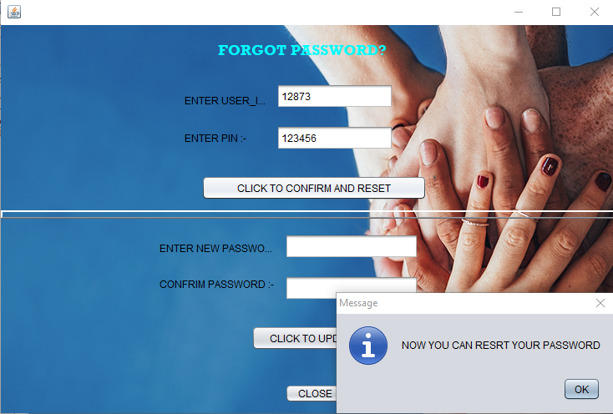

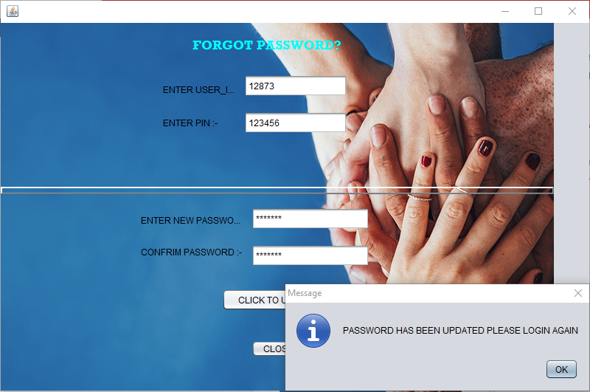

**Coding when “CLICK TO CON……” BUTTON IS CLICKED**

try{

Class.forName("java.sql.DriverManager");

Connection con = DriverManager.getConnection("jdbc:mysql://localhost:3306/salarymanagement","root","");

String A,B,sql;

A=t1.getText();

B=t2.getText();

sql="select * from USERS where USER_ID="+A;

System.out.print(sql);

Statement st=con.createStatement();

ResultSet rs=st.executeQuery(sql);

if(!rs.next())

JOptionPane.showMessageDialog(null,"INCORRECT USER_ID AND PIN PLEASE CROSS-CHECK");

else{

String a=rs.getString("USER_ID");

String b=rs.getString("PIN");

String UA,PA,UA1,PA1;

UA = t1.getText();

PA= t2.getText();

if(UA.equals(a) && PA.equals(b))

{ JOptionPane.showMessageDialog(null,"NOW YOU CAN RESET YOUR PASSWORD");

b1.setVisible(false);

t1.setEditable(false);

t2.setEditable(false);

t3.setVisible(true);

t4.setVisible(true); }

else{

JOptionPane.showMessageDialog(null,"INCORRECT USER_ID AND PIN PLEASE CROSS-CHECK");

} } }

catch(Exception e)

{

JOptionPane.showMessageDialog(null,e.getMessage());

JOptionPane.showMessageDialog(null,"INCORRECT USER_ID AND PIN PLEASE CROSS-CHECK");

} }

**Coding when “CLICK TO UPDTAE” BUTTON IS CLICKED**

try{

Class.forName("java.sql.DriverManager");

Connection con = DriverManager.getConnection("jdbc:mysql://localhost:3306/salarymanagement","root","");

String A,B,sql,c;

c=t1.getText();

A=new String(t3.getPassword());

B=new String(t4.getPassword());

if(A.equals(B)){ sql="Update USERS set password ='"+A+"' where USER_ID ="+c;

Statement st=con.createStatement();

System.out.println(sql);

st.executeUpdate(sql);

JOptionPane.showMessageDialog(null,"PASSWORD HAS BEEN UPDATED PLEASE LOGIN AGAIN");

log_in q = new log_in();

q.setVisible(true);

this.dispose(); }

else{

JOptionPane.showMessageDialog(null,"PASSWORD HAS NOT BEEN UPDATED PLEASE TRY AGAIN");

} }

catch(Exception e)

{

JOptionPane.showMessageDialog(null,e.getMessage());

JOptionPane.showMessageDialog(null,"INCORRECT USER_ID AND PIN PLEASE CROSS-CHECK");

} }

***NEW USER FORM***

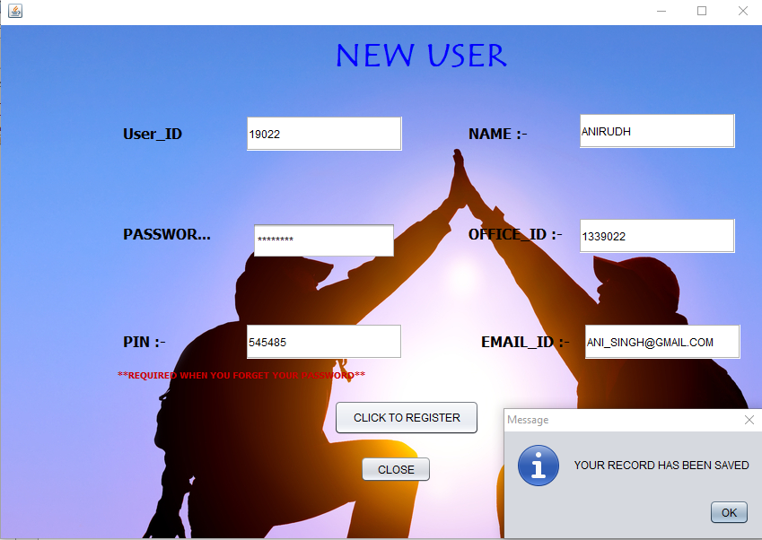

**Coding when “CLICK TO REGISTER” “BUTTON IS CLICKED**

try{

Class.forName("java.sql.DriverManager");

Connection con = DriverManager.getConnection("jdbc:mysql://localhost:3306/salarymanagement","root","");

String a,b,c,d,e,f,sql;

a=t1.getText();

b=new String(t2.getPassword());

c=t3.getText();

d=t4.getText();

e=t5.getText();

f=t6.getText();

if(a.equals("") || b.equals("") || c.equals("") || d.equals("") || e.equals("") || f.equals("")){

JOptionPane.showMessageDialog(null,"PLEASE FILL DETAIL CORRECT");

}

else{

sql="insert into USERS values("+a+",'"+b+"',"+c+",'"+d+"',"+e+",'"+b+"')";

System.out.println(sql);

Statement st =con.createStatement();

st.executeUpdate(sql);

JOptionPane.showMessageDialog(null,"YOUR RECORD HAS BEEN SAVED");

JOptionPane.showMessageDialog(null,"PLEASE SIGN_IN");

log_in i = new log_in();

i.setVisible(true);

dispose();

} }

catch(Exception e)

{

JOptionPane.showMessageDialog(null,e.getMessage());

JOptionPane.showMessageDialog(null,"INCORRECT USER_ID AND PIN PLEASE CROSS-CHECK");

} }

5. Input Screen Design

The **First Screen** of the Project is shown below:



There are **Seven Menus** available in the main form and any one of them can be directly selected to proceed further.

Screen shot of the **First** menu is as given below:

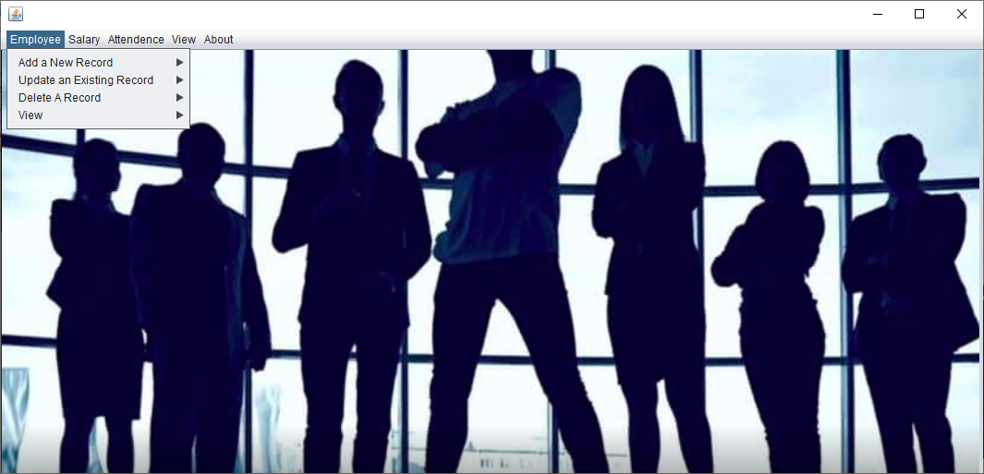

If we select the **Employee → Add New Record** option, the following screen is displayed:

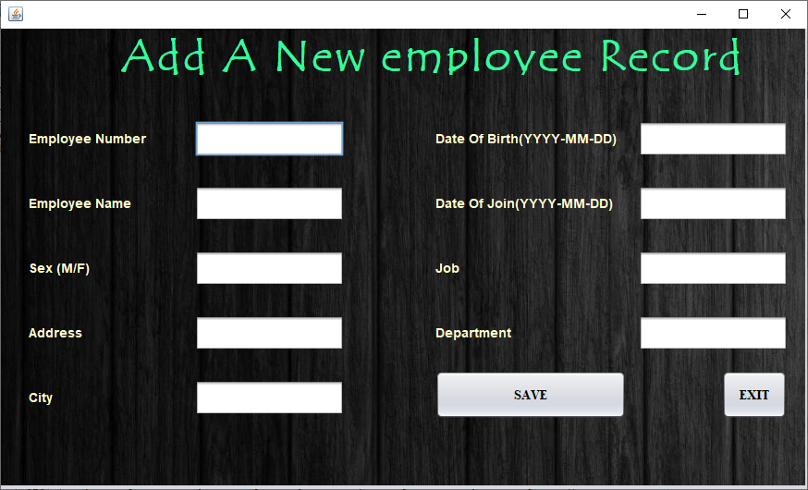

The below coding is used to **ADD Details of the New Employee.**

private void jButton1ActionPerformed(java.awt.event.ActionEvent evt) {

try{

Connection con = DriverManager.getConnection("jdbc:mysql://localhost:3306/salarymanagement","root","");

String empno,ename,sex,address,city,dob,doj,job,department,sql;

empno=T1.getText();

ename=T2.getText();

sex=T3.getText();

address=T4.getText();

city=T5.getText();

dob=T6.getText();

doj=T7.getText();

job=T8.getText();

department=T9.getText();

if(empno.equals("") || ename.equals("") || sex.equals("") || address.equals("") || city.equals("") || dob.equals("") || doj.equals("") || department.equals("") )

{

JOptionPane.showMessageDialog(null,"PLEASE RECHECK THE ENTRIES");

}

else{ sql="insert into employee values("+empno+",'"+ename+"','"+sex+"','"+address+"','"+city+"','"+dob+"','"+doj+"','"+job+"','"+department+"')";

System.out.print(sql);

Statement st=con.createStatement();

st.executeUpdate(sql);

JOptionPane.showMessageDialog(null,"RECORD SAVED");

input_screen s = new input_screen();

s.setVisible(true);

}}

catch(Exception e)

{

JOptionPane.showMessageDialog(this,"ERROR:"+e.getMessage());

}

}

If we select the **Employee → Update Record** option, the following

screen is displayed:

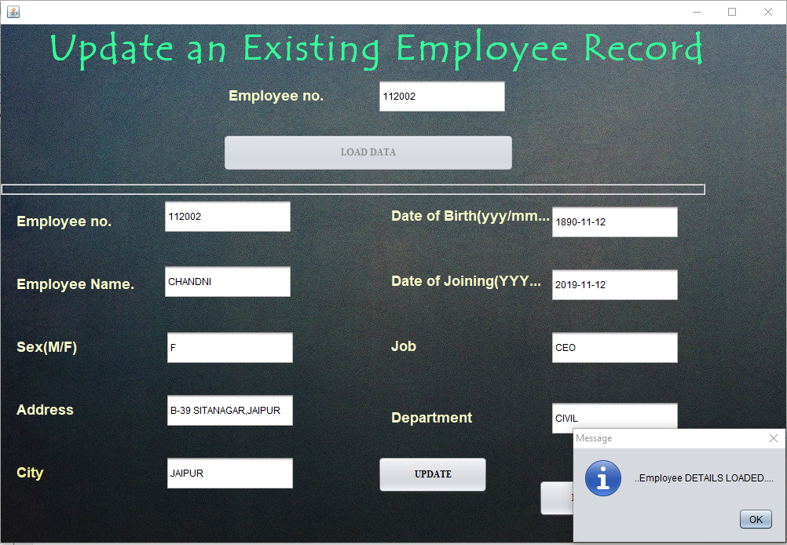

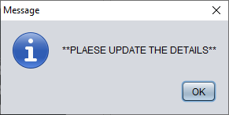

The below coding is used to **UPDATE Details of the New Employee.**

**1.TO UPLOAD DATA**

private void b2ActionPerformed(java.awt.event.ActionEvent evt) {

try{

Connection con = DriverManager.getConnection("jdbc:mysql://localhost:3306/salarymanagement","root","");

String empno,ename="",sex="",address="",city="",dob="",doj="",job="",department="",sql="";

empno=T1.getText();

if(empno.equals(""))

{

JOptionPane.showMessageDialog(null,"PLEASE ENTER THE EMPLOYEE_ID");

T1.requestFocus();

}

else

sql="Select * from Employee where Empno="+empno;

System.out.println(sql);

Statement st=con.createStatement();

ResultSet rs = st.executeQuery(sql);

if(!rs.next()){

JOptionPane.showMessageDialog(null,"..Entered Employee Number DOES NOT EXIST....");

T1.requestFocus();

}

else{b1.setVisible(true);

T1.setEditable(false);

T2.setEditable(false);

T3.setEditable(true);

T4.setEditable(true);

T5.setEditable(true);

T6.setEditable(true);

T7.setEditable(true);

T8.setEditable(true);

T9.setEditable(true);

T10.setEditable(true);

b2.setEnabled(false);

T2.setText(rs.getString("empno"));

T3.setText(rs.getString("ename"));

T4.setText(rs.getString("sex"));

T5.setText(rs.getString("address"));

T6.setText(rs.getString("city"));

T7.setText(rs.getString("DOB"));

T8.setText(rs.getString("DOJ"));

T9.setText(rs.getString("Job"));

T10.setText(rs.getString("Department"));

JOptionPane.showMessageDialog(null,"..Employee DETAILS LOADED....");

JOptionPane.showMessageDialog(null,"**PLAESE UPDATE THE DETAILS**"); }}

catch(Exception e)

{ JOptionPane.showMessageDialog(this,"ERROR:"+e.getMessage());

} }

**1.TO UPDATE DATA**

private void b1ActionPerformed(java.awt.event.ActionEvent evt) {

try{

String empno,ename,sex,add,city,dob,doj,job,department,sql;

Class.forName("java.sql.DriverManager");

Connection con=DriverManager.getConnection("jdbc:mysql://localhost:3306/salarymanagement","root","");

empno=T2.getText();

ename=T3.getText();

sex=T4.getText();

add=T5.getText();

city=T6.getText();

dob=T7.getText();

doj=T8.getText();

job=T9.getText();

department=T10.getText();

if(empno.equals("") || ename.equals("") || sex.equals("") || add.equals("") || city.equals("") || dob.equals("") || doj.equals("") || department.equals("") )

{

JOptionPane.showMessageDialog(null,"PLEASE RECHECK THE ENTRIES");

}

else{sql="UPDATE EMPLOYEE SET Empno="+ empno+",Ename='"+ename+"',Sex='"+sex+"',Address='"+add+"',City='"+city+"',DOB='"+dob+"',DOJ='"+doj+"',Job='"+job+"',Department='"+department+"' where Empno="+empno;

Statement st=con.createStatement();

st.executeUpdate(sql);

System.out.println(sql);

JOptionPane.showMessageDialog(null,"..DATA HAVE BEEN UPDATED..");

}

}

catch(Exception e){

JOptionPane.showMessageDialog(this,e.getMessage());

}

}

private void b2ActionPerformed(java.awt.event.ActionEvent evt) {

try{

Connection con = DriverManager.getConnection("jdbc:mysql://localhost:3306/salarymanagement","root","");

String empno,ename="",sex="",address="",city="",dob="",doj="",job="",department="",sql="";

empno=T1.getText();

if(empno.equals(""))

{

JOptionPane.showMessageDialog(null,"PLEASE ENTER THE EMPLOYEE_ID");

T1.requestFocus();

}

else

sql="Select * from Employee where Empno="+empno;

System.out.println(sql);

Statement st=con.createStatement();

ResultSet rs = st.executeQuery(sql);

if(!rs.next()){

JOptionPane.showMessageDialog(null,"..Entered Employee Number DOES NOT EXIST....");

T1.requestFocus();

}

else{b1.setVisible(true);

T1.setEditable(false);

T2.setEditable(false);

T3.setEditable(true);

T4.setEditable(true);

T5.setEditable(true);

T6.setEditable(true);

T7.setEditable(true);

T8.setEditable(true);

T9.setEditable(true);

T10.setEditable(true);

b2.setEnabled(false);

T2.setText(rs.getString("empno"));

T3.setText(rs.getString("ename"));

T4.setText(rs.getString("sex"));

T5.setText(rs.getString("address"));

T6.setText(rs.getString("city"));

T7.setText(rs.getString("DOB"));

T8.setText(rs.getString("DOJ"));

T9.setText(rs.getString("Job"));

T10.setText(rs.getString("Department"));

JOptionPane.showMessageDialog(null,"..Employee DETAILS LOADED....");

JOptionPane.showMessageDialog(null,"**PLAESE UPDATE THE DETAILS**");

}}

catch(Exception e)

{ JOptionPane.showMessageDialog(this,"ERROR:"+e.getMessage());

} }

If we select the **Employee → Remove Record** option, the following screen is displayed:

The below screen is used to **DELETE** the details of an existing employee.

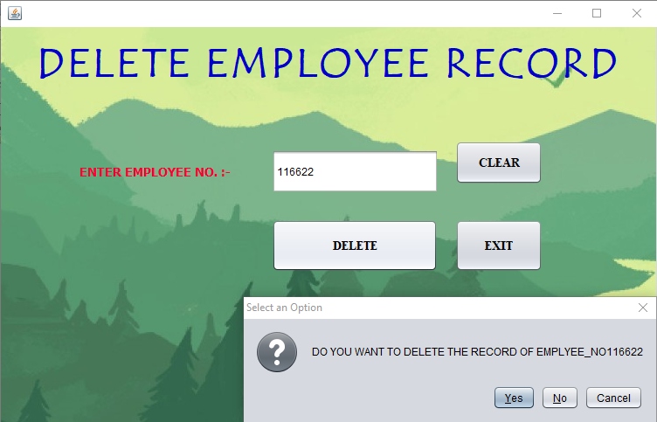

**The below coding for button “DELETE”**

try{

Class.forName("java.sql.DriverManager");

Connection con = DriverManager.getConnection("jdbc:mysql://localhost:3306/salarymanagement","root","");

String a,b,c,d,e,f,sql;

a=t1.getText();

if(a.equals("")){

JOptionPane.showMessageDialog(null,"PLEASE ENETR EMPLOYEE_NO.");

}

else{

int dialogButton = JOptionPane.showConfirmDialog(this,"DO YOU WANT TO DELETE THE RECORD OF EMPLYEE_NO"+a);

if(dialogButton == JOptionPane.YES_OPTION)

{

sql="Delete from EMPLOYEE where empno="+a;

System.out.println(sql);

Statement st =con.createStatement();

st.executeUpdate(sql);

JOptionPane.showMessageDialog(null,"RECORD SUCESSFULLY DELETED");

dispose();

input_screen iv = new input_screen();

iv.setVisible(true);

}}}

catch(Exception e)

{ JOptionPane.showMessageDialog(null,e.getMessage()); }

}

If we select the **Employee →View,** the following screen is displayed:

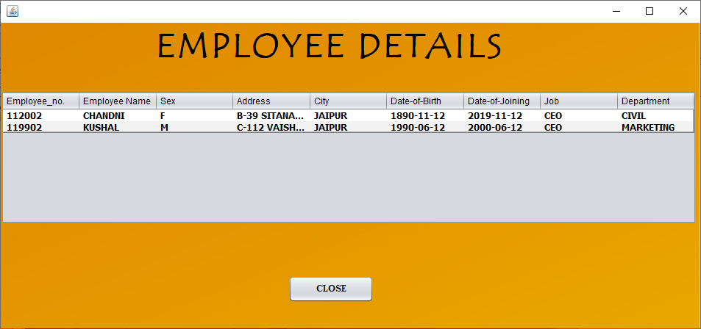

The above screen is used to **VIEW** details of the Employees.

**//CODING TO VIEW EMPLOYEE DETAILS**

public view() {

initComponents();

DefaultTableModel model=(DefaultTableModel)t1.getModel();

try{

Class.forName("java.sql.DriverManager");

java.sql.Connection con = DriverManager.getConnection("jdbc:mysql://localhost:3306/salarymanagement","root","");

Statement st=con.createStatement();

String sql="Select * from Employee";

ResultSet rs = st.executeQuery(sql);

int row = model.getRowCount();

if(row>0){

for(int i=0;i<row;i++){

model.removeRow(0);

}

while(rs.next()){

String empno,ename="",sex="",address="",city="",dob="",doj="",job="",department="";

empno=rs.getString("empno");

ename=rs.getString("ename");

sex=rs.getString("sex");

address=rs.getString("address");

city=rs.getString("city");

dob=rs.getString("DOB");

doj=rs.getString("DOJ");

job=rs.getString("Job");

department=rs.getString("Department");

model.addRow(new Object[]{empno,ename,sex,address,city,dob,doj,job,department});

}

}if(row==0)

{

JOptionPane.showMessageDialog(this,"No Record Found");

rs.close();

st.close();

con.close();

}

}

catch(Exception e)

{

JOptionPane.showMessageDialog(this,"Error :"+e);

JOptionPane.showMessageDialog(null,"INCORRECT USER_ID AND PIN PLEASE CROSS-CHECK");

}

}

Screenshot of the **Second** **Menu** is as:

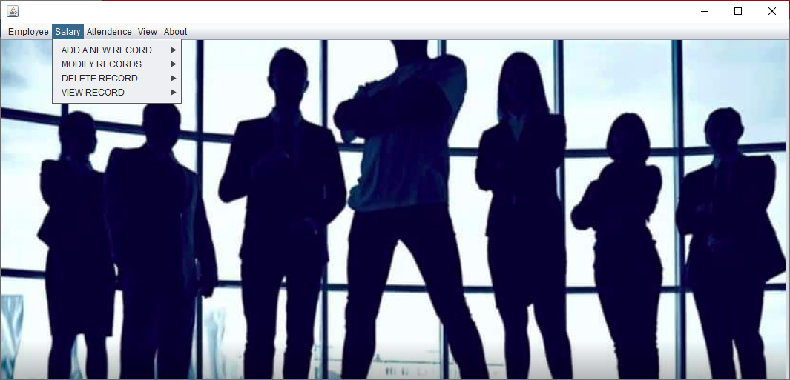

If we select the **Salary → Add New Record** option, the following screen is displayed:

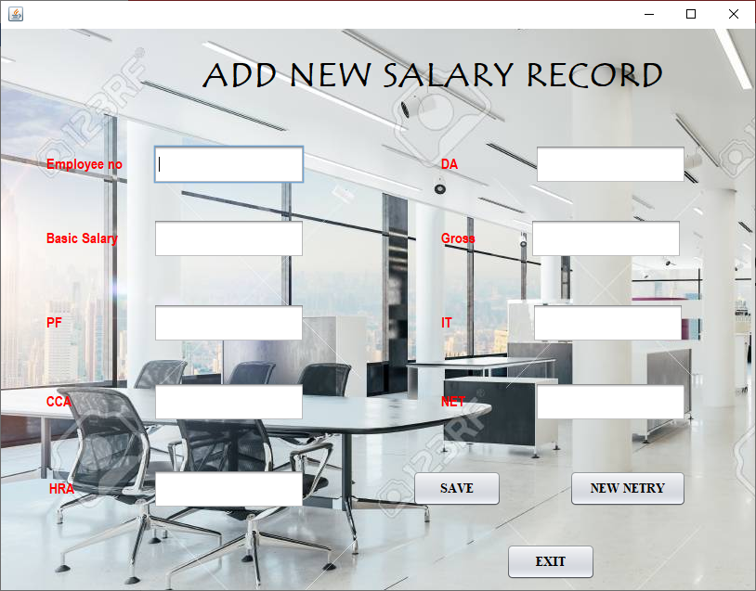

The above screen is used to enter **details of the new Employee Salary.**

**//CODING FOR”SAVE” BUTTON**

private void b1ActionPerformed(java.awt.event.ActionEvent evt) {

try{

Class.forName("java.sql.DriverManager");

java.sql.Connection con = DriverManager.getConnection("jdbc:mysql://localhost:3306/salarymanagement","root","");

String empno,sql;

double bassal,pf,cca,hra,da,gross,it,net;

empno=t1.getText();

bassal=Double.parseDouble(t2.getText());

if(empno.equals(""))

{

JOptionPane.showMessageDialog(null,"PLEASE CROSS-CHECK THE ENTERIES");

}

else

{

Double bas=bassal;

pf=0.12*bas;

cca=1000;

if(bas>=20000)

{hra=4250; }

else if(bas>=15000)

{ hra=4000; }

else if(bas>=10000)

{hra=3750; }

else

{hra=3500; }

if(bas>=20000)

{da=2100; }

else if(bas>=10000)

{da=1800; }

else

{da=1500; }

gross=bas+cca+hra+da;

if(gross>=25000)

{it=0.06*gross; }

else if(gross>=20000)

{it=0.04*gross; }

else if(gross>=15000)

{it=0.02*gross; }

else

{it=0.01*gross; }

net=gross-pf-it;

t3.setText(Double.toString(pf));

t4.setText(Double.toString(cca));

t5.setText(Double.toString(hra));

t6.setText(Double.toString(da));

t7.setText(Double.toString(gross));

t8.setText(Double.toString(it));

t9.setText(Double.toString(net));

sql="insert into salary values("+empno+",'"+bas+"','"+pf+"','"+cca+"','"+hra+"','"+da+"','"+gross+"','"+it+"','"+net+"')";

Statement st=con.createStatement();

st.executeUpdate(sql);

JOptionPane.showMessageDialog(null,"Record has been SAVED");

t1.setEditable(false);

t2.setEditable(false);

t3.setEditable(false);

t4.setEditable(false);

t5.setEditable(false);

t6.setEditable(false);

t7.setEditable(false);

t8.setEditable(false);

t9.setEditable(false);

b1.setVisible(false); } }

catch(Exception e)

{ JOptionPane.showMessageDialog(this,"Error :"+e); } }

If we select the **Salary → Update Existing Record** option the following screen is displayed.

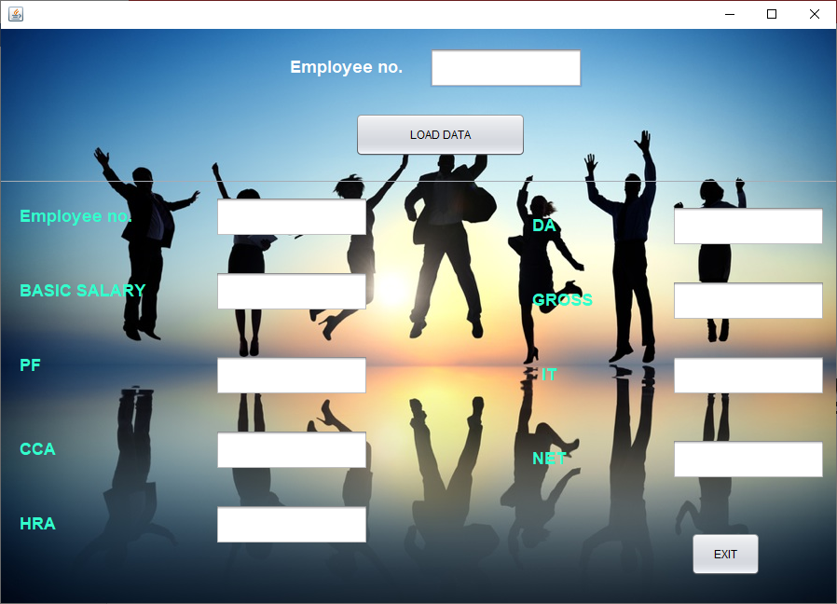

The above screen is used to **UPDATE** the existing salary record.

After entering the correct employee number and clicking the **‘Load Data’** button,

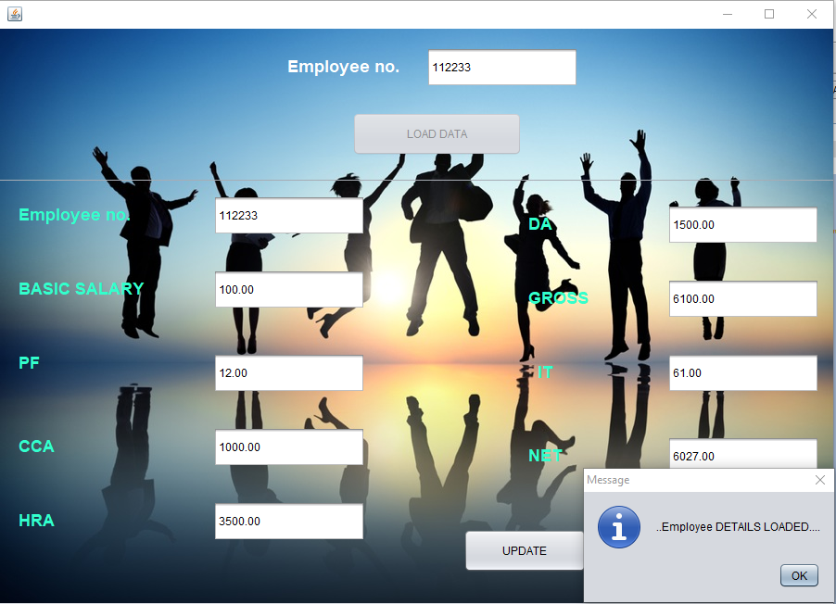

**//CODING FOR “LOAD DATA” BUTTON**

private void b2ActionPerformed(java.awt.event.ActionEvent evt) {

try{

Connection con = DriverManager.getConnection("jdbc:mysql://localhost:3306/salarymanagement","root","");

String empno,sql="";

empno=T1.getText();

if(empno.equals(""))

{

JOptionPane.showMessageDialog(null,"PLEASE ENTER THE EMPLOYEE_ID");

T1.requestFocus();

}

else

sql="Select * from salary where Empno="+empno;

System.out.println(sql);

Statement st=con.createStatement();

ResultSet rs = st.executeQuery(sql);

if(!rs.next()){

JOptionPane.showMessageDialog(null,"..Entered Employee Number DOES NOT EXIST....");

T1.requestFocus();

}

else{b1.setVisible(true);

T1.setEditable(false);

T2.setEditable(true);

T3.setEditable(true);

b2.setEnabled(false);

T2.setText(rs.getString("empno"));

T3.setText(rs.getString("basic"));

T4.setText(rs.getString("pf"));

T5.setText(rs.getString("cca"));

T6.setText(rs.getString("hra"));

T7.setText(rs.getString("da"));

T8.setText(rs.getString("gross"));

T9.setText(rs.getString("it"));

T10.setText(rs.getString("net"));

JOptionPane.showMessageDialog(null,"..Employee DETAILS LOADED....");

JOptionPane.showMessageDialog(null,"**PLAESE UPDATE THE DETAILS**"); } }

catch(Exception e)

{ JOptionPane.showMessageDialog(this,"ERROR:"+e.getMessage());

}

}

After modifying the **Basic Salary**, **‘Save’** button should be pressed.

**//CODING FOR “UPDATE” BUTTON**

private void b1ActionPerformed(java.awt.event.ActionEvent evt) {

try{

String empno,sql;

Double basicsal,pf,cca,hra,da,gross,it,net;

Class.forName("java.sql.DriverManager");

Connection con=DriverManager.getConnection("jdbc:mysql://localhost:3306/salarymanagement","root","");

empno=T2.getText();

basicsal=Double.parseDouble(T3.getText());

pf=Double.parseDouble(T4.getText());

cca=Double.parseDouble(T5.getText());

hra=Double.parseDouble(T6.getText());

da=Double.parseDouble(T7.getText());

gross=Double.parseDouble(T8.getText());

it=Double.parseDouble(T9.getText());

net=Double.parseDouble(T10.getText());

if(empno.equals("") || Objects.equals(basicsal, ""))

{

JOptionPane.showMessageDialog(null,"PLEASE RECHECK THE ENTRIES");

}

else

{

Double bas=basicsal;

pf=0.12*bas;

cca=1000.00;

if(bas>=20000)

{

hra=4250.00;

}

else if(bas>=15000)

{

hra=4000.00;

}

else if(bas>=10000)

{

hra=3750.00;

}

else

{

hra=3500.00;

}

if(bas>=20000)

{

da=2100.00;

}

else if(bas>=10000)

{

da=1800.00;

}

else

{

da=1500.00;

}

gross=bas+cca+hra+da;

if(gross>=25000)

{

it=0.06*gross;

}

else if(gross>=20000)

{

it=0.04*gross;

}

else if(gross>=15000)

{

it=0.02*gross;

}

else

{

it=0.01*gross;

}

net=gross-pf-it;

T4.setText(Double.toString(pf));

T5.setText(Double.toString(cca));

T6.setText(Double.toString(hra));

T7.setText(Double.toString(da));

T7.setText(Double.toString(gross));

T8.setText(Double.toString(it));

T10.setText(Double.toString(net));

Double bassaal= Double.parseDouble(T3.getText());

int a= Integer.parseInt(T2.getText());

sql="UPDATE salary SET Empno='"+ a+"',Basic='"+bassaal+"',pf='"+pf+"',cca='"+cca+"',hra='"+hra+"',da='"+da+"',gross='"+gross+"',it='"+it+"',net='"+net+"' where Empno="+empno;

Statement st=con.createStatement();

st.executeUpdate(sql);

System.out.println(sql);

JOptionPane.showMessageDialog(null,"..DATA HAVE BEEN UPDATED..");

}

}

catch(Exception e){

JOptionPane.showMessageDialog(this,e.getMessage());

}

}

If we select the **Salary → Remove Record** option, the following screen is displayed:

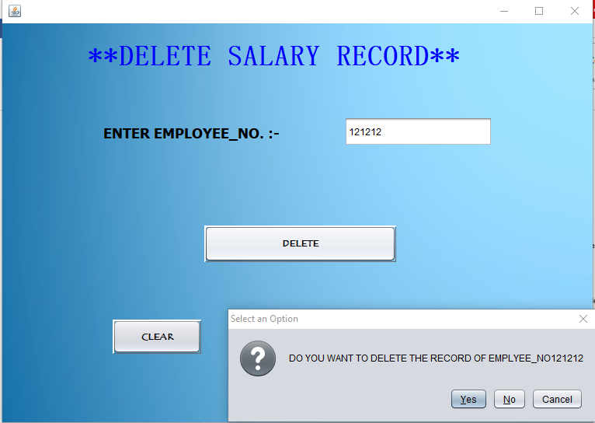

The above screen is used to **DELETE** the details of an existing Employee Salary.

**//CODING FOR “DELETE” BUTTON**

private void jButton1ActionPerformed(java.awt.event.ActionEvent evt) {

try{

Class.forName("java.sql.DriverManager");

Connection con = DriverManager.getConnection("jdbc:mysql://localhost:3306/salarymanagement","root","");

String a,b,c,d,e,f,sql;

a=t1.getText();

if(a.equals("")){

JOptionPane.showMessageDialog(null,"PLEASE ENETR EMPLOYEE_NO.");

}

else{

int dialogButton = JOptionPane.showConfirmDialog(this,"DO YOU WANT TO DELETE THE RECORD OF EMPLYEE_NO"+a);

if(dialogButton == JOptionPane.YES_OPTION)

{

sql="Delete from salary where empno="+a;

System.out.println(sql);

Statement st =con.createStatement();

st.executeUpdate(sql);

JOptionPane.showMessageDialog(null,"RECORD SUCESSFULLY DELETED");

dispose();

input_screen iv = new input_screen();

iv.setVisible(true);

}}}

catch(Exception e)

{

JOptionPane.showMessageDialog(null,e.getMessage());

} }

If we select the **Salary →View option,** the following screen is displayed:

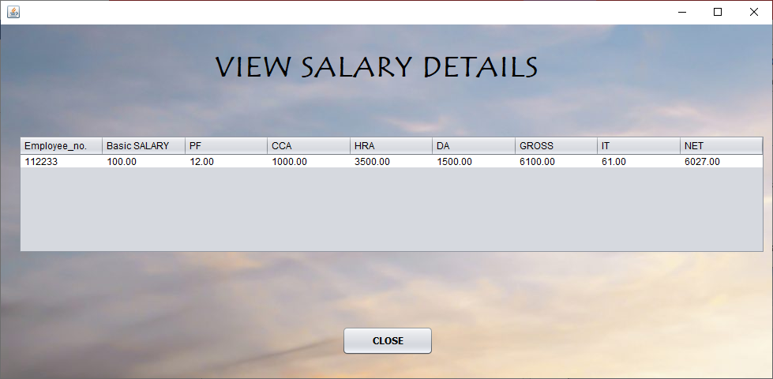

The above screen is used to **VIEW** the details of the Employee Salaries.

**//CODING TO VIEW SALARY DETAILS**

public VIEW_SAALRY_RECORDS() {

initComponents();

DefaultTableModel model=(DefaultTableModel)t1.getModel();

try{

Class.forName("java.sql.DriverManager");

java.sql.Connection con = DriverManager.getConnection("jdbc:mysql://localhost:3306/salarymanagement","root","");

Statement st=con.createStatement();

String sql="Select * from salary";

ResultSet rs = st.executeQuery(sql);

int row = model.getRowCount();

if(row>0){

for(int i=0;i<row;i++){

model.removeRow(0); }

while(rs.next()){

String empno,bas="",pf="",cca="",hra="",da="",gross="",it="",net="";

empno=rs.getString("empno");

bas=rs.getString("basic");

pf=rs.getString("pf");

cca=rs.getString("cca");

hra=rs.getString("hra");

da=rs.getString("da");

gross=rs.getString("gross");

it=rs.getString("it");

net=rs.getString("net");

model.addRow(new Object[]{empno,bas,pf,cca,hra,da,gross,it,net});}

}if(row==0)

{JOptionPane.showMessageDialog(this,"No Record Found");

rs.close();

st.close();

con.close();

}}

catch(Exception e)

{

JOptionPane.showMessageDialog(this,"Error :"+e);

JOptionPane.showMessageDialog(null,"INCORRECT USER_ID AND PIN PLEASE CROSS-CHECK");

} }

Screenshot of the **Third** **Menu** is as:

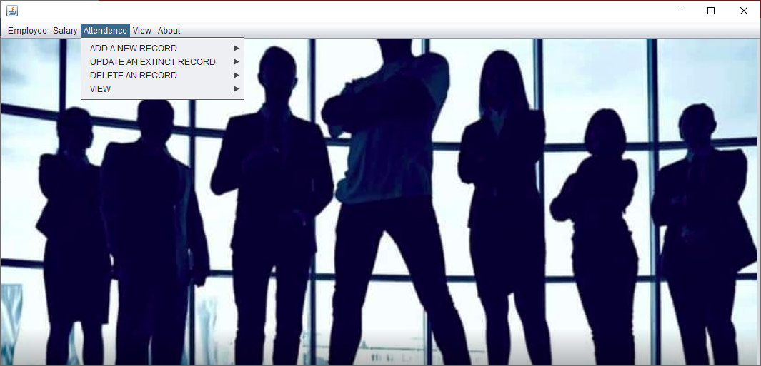

If we select the **Attendance → Add New Record** option, the following screen is displayed:

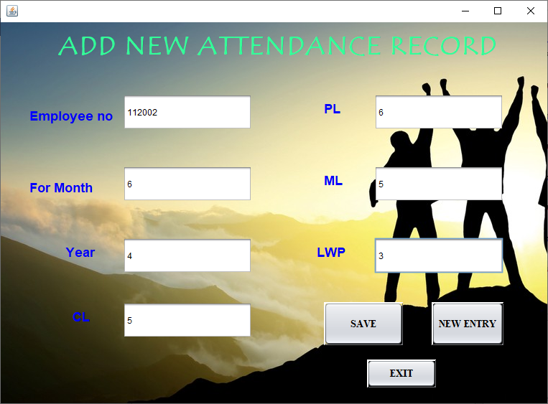

The above screen is used to enter **attendance details of an employee.**

**//CODING FOR”SAVE” BUTTON**

private void b1ActionPerformed(java.awt.event.ActionEvent evt) {

try{

Class.forName("java.sql.DriverManager");

java.sql.Connection con = DriverManager.getConnection("jdbc:mysql://localhost:3306/salarymanagement","root","");

String empno,sql;

String formonth,year,cl,pl,ml,lwp;

empno=t1.getText();

formonth=t2.getText();

year=t3.getText();

cl=t4.getText();

pl=t5.getText();

ml=t6.getText();

lwp=t7.getText();

if(empno.equals("") || formonth.equals("") || year.equals("") || cl.equals("") || pl.equals("") || ml.equals("") || lwp.equals(""))

{

JOptionPane.showMessageDialog(null,"PLEASE RECHECK THE ENTRIES");

}

else

{

sql="insert into attendance values("+empno+",'"+formonth+"','"+year+"','"+cl+"','"+pl+"','"+ml+"','"+lwp+"')";

Statement st=con.createStatement();

st.executeUpdate(sql);

JOptionPane.showMessageDialog(null,"Record has been SAVED");

t1.setEditable(false);

t2.setEditable(false);

t3.setEditable(false);

t4.setEditable(false);

t5.setEditable(false);

t6.setEditable(false);

t7.setEditable(false);

b1.setVisible(false);

} }catch(Exception e)

{ JOptionPane.showMessageDialog(this,"Error :"+e);

} }

If we select the **Attendance → Update existing record** option the following screen is displayed.

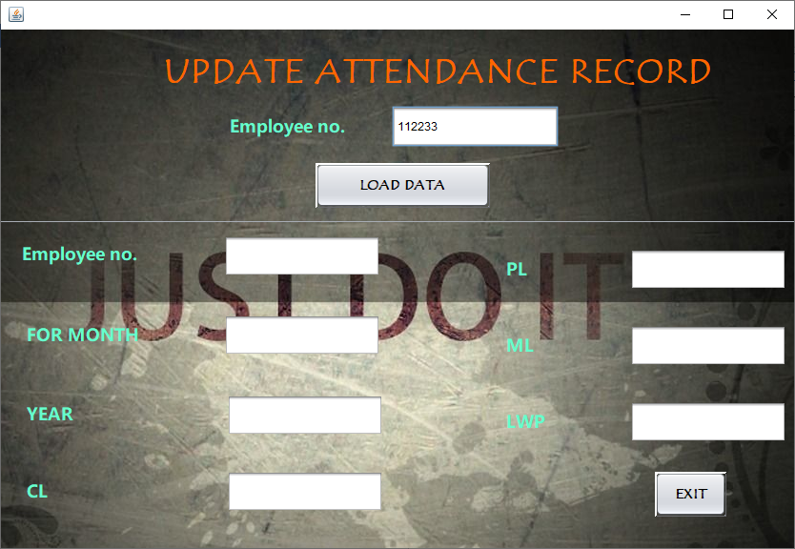

The above screen is used to **UPDATE** the **Attendance** details **like that of Employee details.**

After entering the correct employee number and clicking the **‘Load Data’** button,

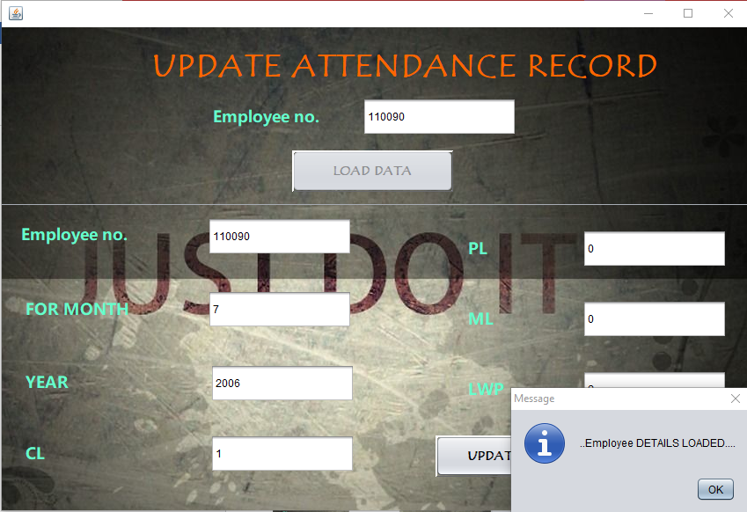

**//CODING FOR “LOAD DATA” BUTTON**

Connection con = DriverManager.getConnection("jdbc:mysql://localhost:3306/salarymanagement","root","");

String empno,sql="";

empno=T1.getText();

if(empno.equals(""))

{

JOptionPane.showMessageDialog(null,"PLEASE ENTER THE EMPLOYEE_ID");

T1.requestFocus();

}

else

sql="Select * from attendance where Empno="+empno;

System.out.println(sql);

Statement st=con.createStatement();

ResultSet rs = st.executeQuery(sql);

if(!rs.next()){

JOptionPane.showMessageDialog(null,"..Entered Employee Number DOES NOT EXIST....");

T1.requestFocus();

}

else{b1.setVisible(true);

T1.setEditable(true);

T2.setEditable(true);

T3.setEditable(true);

T4.setEditable(true);

T5.setEditable(true);

T6.setEditable(true);

T7.setEditable(true);

b2.setEnabled(false);

T2.setText(rs.getString("empno"));

T3.setText(rs.getString("for_month"));

T4.setText(rs.getString("year"));

T5.setText(rs.getString("cl"));

T6.setText(rs.getString("pl"));

T7.setText(rs.getString("ml"));

T8.setText(rs.getString("lwp"));

JOptionPane.showMessageDialog(null,"..Employee DETAILS LOADED....");

JOptionPane.showMessageDialog(null,"**PLAESE UPDATE THE DETAILS**");

}}

catch(Exception e)

{JOptionPane.showMessageDialog(this,"ERROR:"+e.getMessage()); }

}

**//CODING FOR “UPDTAE BUTTON”**

private void b1ActionPerformed(java.awt.event.ActionEvent evt) {

try{

String empno,month,year,cl,pl,ml,lwp,sql;

Class.forName("java.sql.DriverManager");

Connection con=DriverManager.getConnection("jdbc:mysql://localhost:3306/salarymanagement","root","");

empno=T2.getText();

month=T3.getText();

year=T4.getText();

cl=T5.getText();

pl=T6.getText();

ml=T7.getText();

lwp=T8.getText();

if(empno.equals("") || month.equals("") || year.equals("") || cl.equals("") || pl.equals("") || ml.equals("") || lwp.equals(""))

{

JOptionPane.showMessageDialog(null,"PLEASE RECHECK THE ENTRIES");

}

else

{

sql="UPDATE attendance SET Empno="+ empno+",for_month='"+month+"',year='"+year+"',cl='"+cl+"',pl='"+pl+"',ml='"+ml+"',lwp='"+lwp+"' where Empno="+empno;

Statement st=con.createStatement();

st.executeUpdate(sql);

System.out.println(sql);

JOptionPane.showMessageDialog(null,"..DATA HAVE BEEN UPDATED..");

}

}

catch(Exception e){

JOptionPane.showMessageDialog(this,e.getMessage());

}

}

If we select the **Attendance → Remove Record** option, the following screen is displayed:

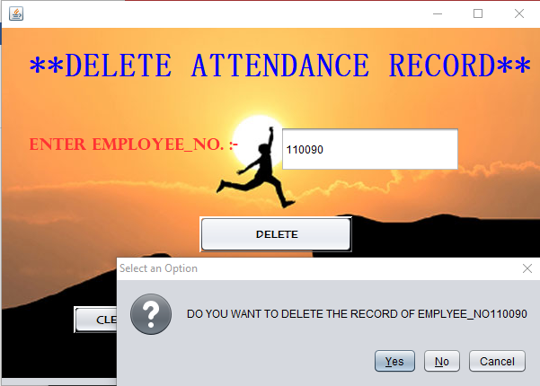

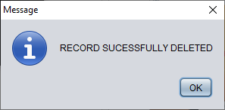

The above screen is used to **DELETE** the attendance details of an employee.

**//CODING FOR “DELETE” BUTTON**

private void jButton1ActionPerformed(java.awt.event.ActionEvent evt) {

try{

Class.forName("java.sql.DriverManager");

Connection con = DriverManager.getConnection("jdbc:mysql://localhost:3306/salarymanagement","root","");

String a,b,c,d,e,f,sql;

a=t1.getText();

if(a.equals("")){

JOptionPane.showMessageDialog(null,"PLEASE ENETR EMPLOYEE_NO.");

}

else{

int dialogButton = JOptionPane.showConfirmDialog(this,"DO YOU WANT TO DELETE THE RECORD OF EMPLYEE_NO"+a);

if(dialogButton == JOptionPane.YES_OPTION)

{

sql="Delete from ATTENDANCE where empno="+a;

System.out.println(sql);

Statement st =con.createStatement();

st.executeUpdate(sql);

JOptionPane.showMessageDialog(null,"RECORD SUCESSFULLY DELETED");

dispose();

input_screen iv = new input_screen();

iv.setVisible(true);

}}}

catch(Exception e)

{

JOptionPane.showMessageDialog(null,e.getMessage()); } }

If we select the **Attendance →View option,** the following screen is displayed: 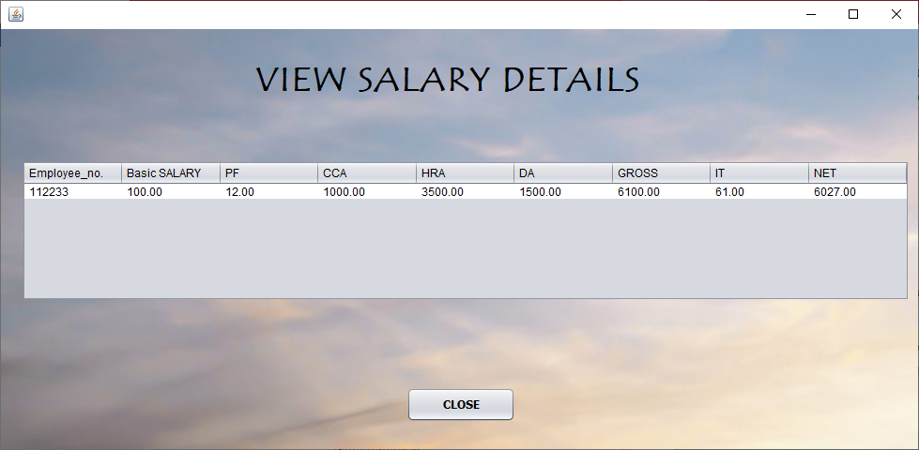

The above screen is used to **VIEW** the attendance details of an employee.

**//CODING TO VIEW ATTENDANCE RECORD**

public VIEW_ATTENDANCE() {

initComponents();

DefaultTableModel model=(DefaultTableModel)t1.getModel();

try{

Class.forName("java.sql.DriverManager");

java.sql.Connection con = DriverManager.getConnection("jdbc:mysql://localhost:3306/salarymanagement","root","");

Statement st=con.createStatement();

String sql="Select * from ATTENDANCE";

ResultSet rs = st.executeQuery(sql);

int row = model.getRowCount();

if(row>0){

for(int i=0;i<row;i++){

model.removeRow(0);

}

while(rs.next()){

String empno,month="",year="",cl="",pl="",ml="",lwp="";

empno=rs.getString("empno");

month=rs.getString("for_month");

year=rs.getString("year");

cl=rs.getString("cl");

pl=rs.getString("pl");

ml=rs.getString("ml");

lwp=rs.getString("lwp");

model.addRow(new Object[]{empno,month,year,cl,pl,ml,lwp});

}

}if(row==0)

{

JOptionPane.showMessageDialog(this,"No Record Found");

rs.close();

st.close();

con.close();

} }

catch(Exception e)

{

JOptionPane.showMessageDialog(this,"Error :"+e);

JOptionPane.showMessageDialog(null,"INCORRECT USER_ID AND PIN PLEASE CROSS-CHECK");

}

}

***FOR CLOSE BUTTON***

private void jButton2ActionPerformed(java.awt.event.ActionEvent evt) {

int a=JOptionPane.showConfirmDialog(this,"Are you sure You want To exit");

if(a==JOptionPane.YES_OPTION)

{

dispose();

input_screen s = new input_screen();

s.setVisible(true);

}

}

If we select **View→View Employee and Salary Records** the following screen is displayed.

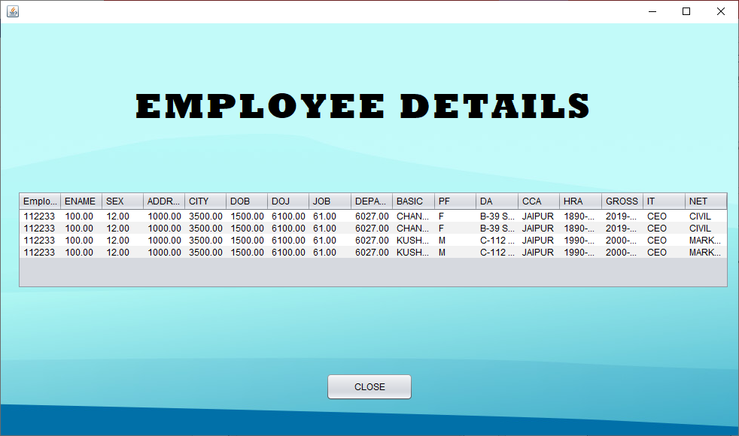

**//CODNG TO VIEW THE *EMPLOYEE* DETAIL**

public view_salaryattendanceemployee() {

initComponents();

DefaultTableModel model=(DefaultTableModel)t1.getModel();

try{

Class.forName("java.sql.DriverManager");

java.sql.Connection con = DriverManager.getConnection("jdbc:mysql://localhost:3306/salarymanagement","root","");

Statement st=con.createStatement();

String sql="Select * from salary,attendance,employee";

ResultSet rs = st.executeQuery(sql);

int row = model.getRowCount();

if(row>0){

for(int i=0;i<row;i++){

model.removeRow(0);

}

while(rs.next()){

String empno,bas="",pf="",cca="",hra="",da="",gross="",it="",net="",ename="",sex="",address="",city="",dob="",doj="",job="",dept="";

empno=rs.getString("empno");

bas=rs.getString("basic");

pf=rs.getString("pf");

cca=rs.getString("cca");

hra=rs.getString("hra");

da=rs.getString("da");

gross=rs.getString("gross");

it=rs.getString("it");

net=rs.getString("net");

empno=rs.getString("empno");

ename=rs.getString("ename");

sex=rs.getString("sex");

address=rs.getString("address");

city=rs.getString("city");

dob=rs.getString("dob");

doj=rs.getString("doj");

job=rs.getString("job");

dept=rs.getString("department");

model.addRow(new Object[]{empno,bas,pf,cca,hra,da,gross,it,net,ename,sex,address,city,dob,doj,job,dept});

}

}if(row==0)

{

JOptionPane.showMessageDialog(this,"No Record Found");

rs.close();

st.close();

con.close();

}}

catch(Exception e)

{

JOptionPane.showMessageDialog(this,"Error :"+e);

JOptionPane.showMessageDialog(null,"INCORRECT USER_ID AND PIN PLEASE CROSS-CHECK");

}

}

On clicking the **About** menu which is **Fifth** menu of the system, the following screen is displayed:

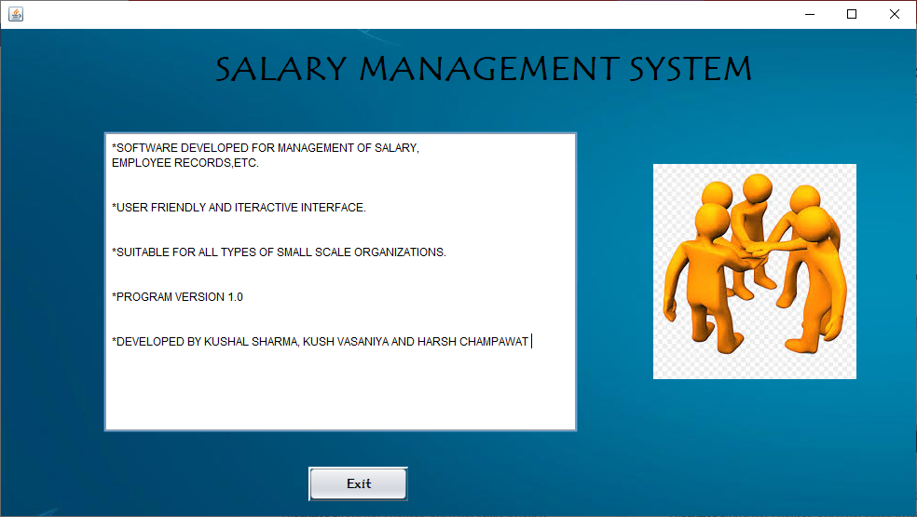

On clicking the **Sixth** **Menu** which is **Exit** menu, the following screen is displayed.

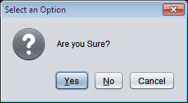

On clicking **‘Yes’** button, the application is closed.

7. Data Dictionary

Various tables used in this project are as follows:

|  |  |  |
| --- | --- | --- |
| Serial No. | Table Name | Uses |
| 1. | Employee | To hold the employee records. |
| 2. | Salary | To hold the employee salary records. |
| 3. | Attendance | To hold the employee attendance records. |

EMPLOYEE

|  |  |  |  |
| --- | --- | --- | --- |
| Data Name | Data Type | Size | Constraint |
| Empno | Integer | 5 | Primary Key |
| Ename | Varchar | 30 |  |
| Sex | Varchar | 2 |  |
| Address | Varchar | 40 |  |
| City | Varchar | 25 |  |
| DOB | Date |  |  |
| DOJ | Date |  |  |
| Job | Varchar | 20 |  |
| Department | Varchar | 20 |  |

SALARY

|  |  |  |  |
| --- | --- | --- | --- |
| Data Name | Data Type | Size | Constraint |
| Empno | Integer | 5 | Primary Key |
| Basic | Numeric | (7,2) |  |
| PF | Numeric | (6,2) |  |
| CCA | Numeric | (6,2) |  |
| HRA | Numeric | (6,2) |  |
| DA | Numeric | (6,2) |  |
| Gross | Numeric | (6,2) |  |
| IT | Numeric | (6,2) |  |
| Net | Numeric | (6,2) |  |

ATTENDANCE

|  |  |  |  |
| --- | --- | --- | --- |
| Data Name | Data Type | Size | Constraint |
| Empno | Integer | 5 | Primary Key |
| For_Month | Integer | 2 |  |
| Year | Integer | 4 |  |
| CL | Integer | 2 |  |
| PL | Integer | 2 |  |
| ML | Integer | 2 |  |
| LWP | Integer | 2 |  |